================================视图=======================

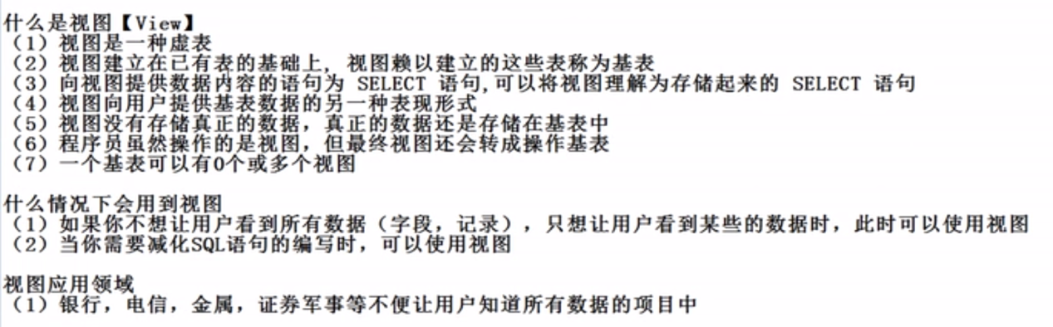

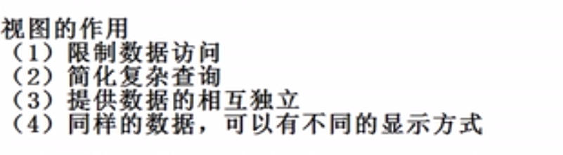

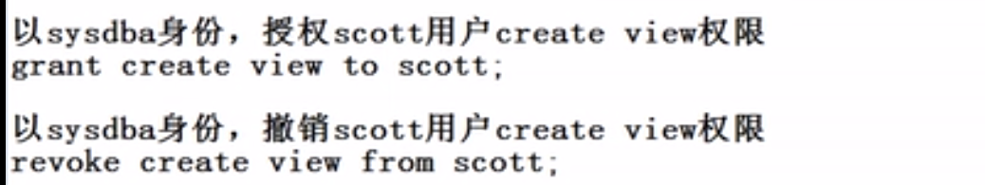

Grant create view to scott;

撤销权限

Revoke create view from scott;

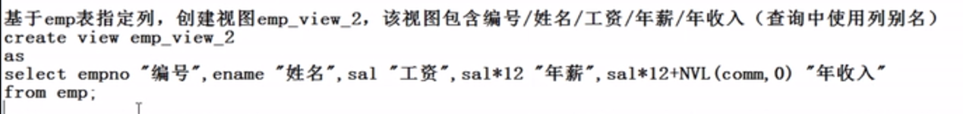

create view emp_view2 as

select empno "编号",ename "姓名",sal "工资",sal*12 "年薪",sal*12+nvl(comm,0) "年收入"

from emp;

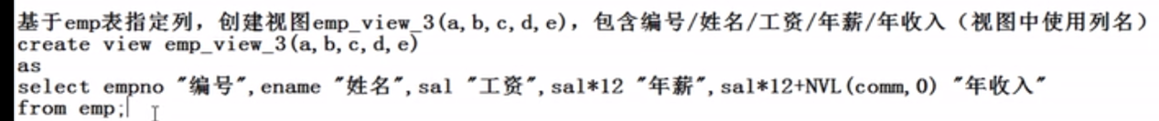

create or replace view emp_view3(a,b,c,d,e) as select empno "编号",ename "姓名",sal "工资",sal*12 "年薪",sal*12+nvl(comm,0) "年收入" from emp; 注意：

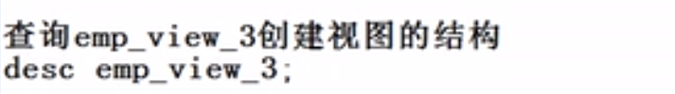

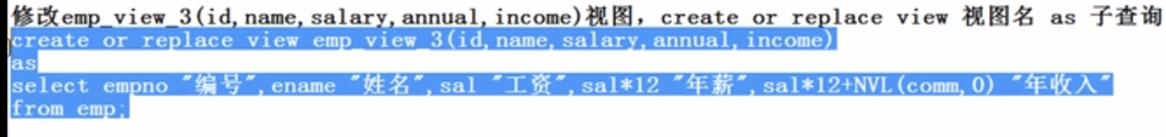

create or replace view emp_view3(id,name,salary,annual,income) as select empno "编号",ename "姓名",sal "工资",sal*12 "年薪",sal*12+nvl(comm,0) "年收入" from emp; 注意：

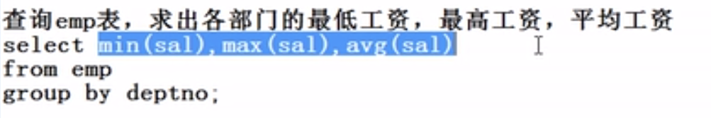

Select min(sal),max(sal),avg(sal) from emp group by deptno;

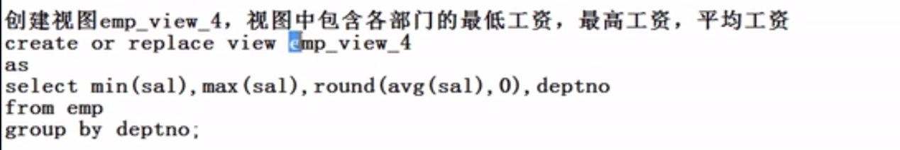

Create view emp_view4 as Select deptno "部门编号" ，min(sal) "最低工资",max(sal) "最高工资",round(avg(sal),0) "平均工资 " from emp group by deptno; **注意，必须要用别名，否则报错**

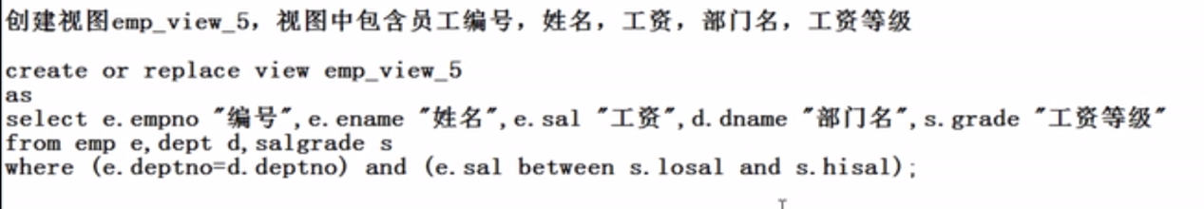

Create view emp_view5 as Select e.empno "编号" ，e.ename "姓名",e.sal "工资",d.dname "部门名" , s.grade "工资等级" from emp e,dept d,salgrade s where (e.deptno=d.deptno) and (e.sal between s.losal and s.hisal);



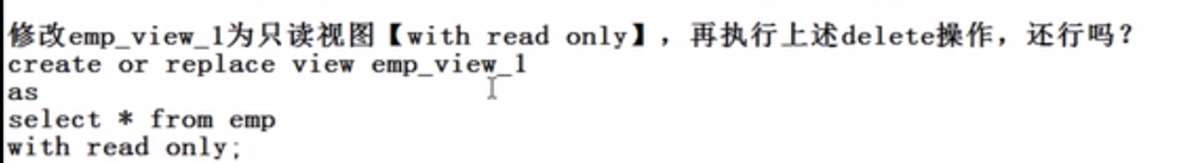

**既然是只读，当然不能进行增删改操作**

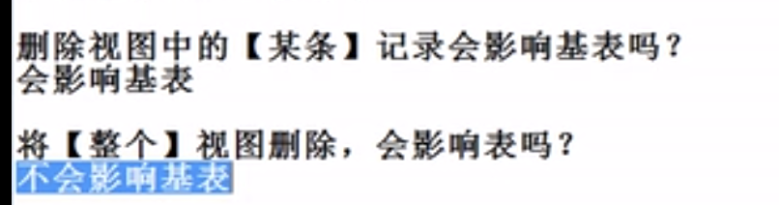

**视图操作的就是基表的数据，删除视图中的数据是会影响基表的，但是删除整个视图不影响基表**

**=================同义词==================**

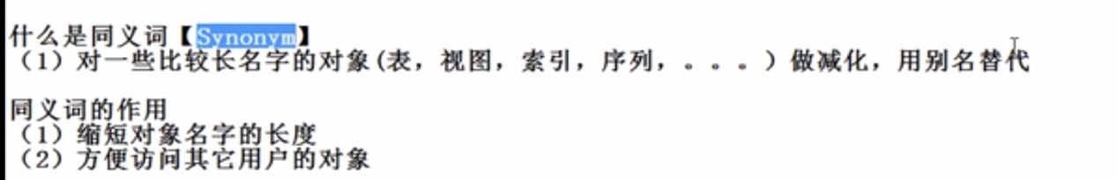



**Create synonym sg for salgrade;**

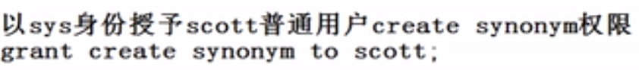

**Grant create synonym to scott;**



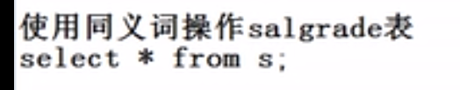

**删除同义词：**

**Drop synonym同义词名称;**

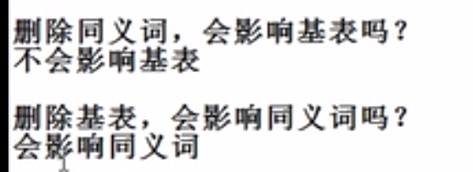

**=====================序列=====================**

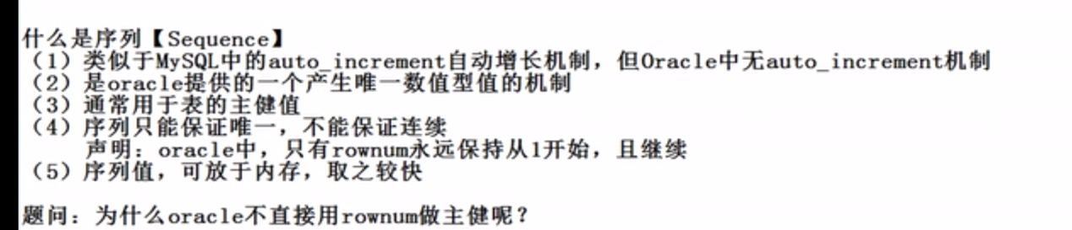

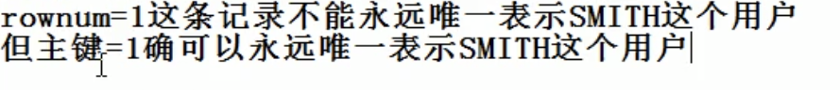

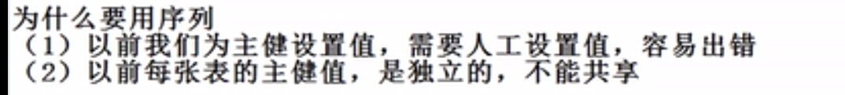



**Create sequence emp_empno_seq;**

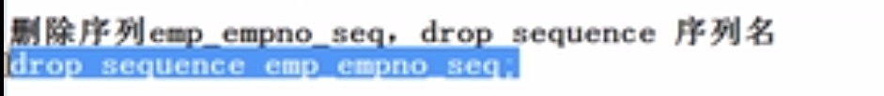

**Drop sequence emp_empno_seq;**

**注意：序列不可查看，也不可用desc，但是可以查询下一个值和当前值，初次使用要用nextVal**

**如：select emp_empno_seq.nextval from dual;**



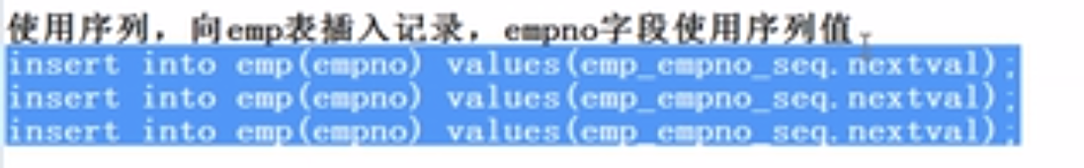

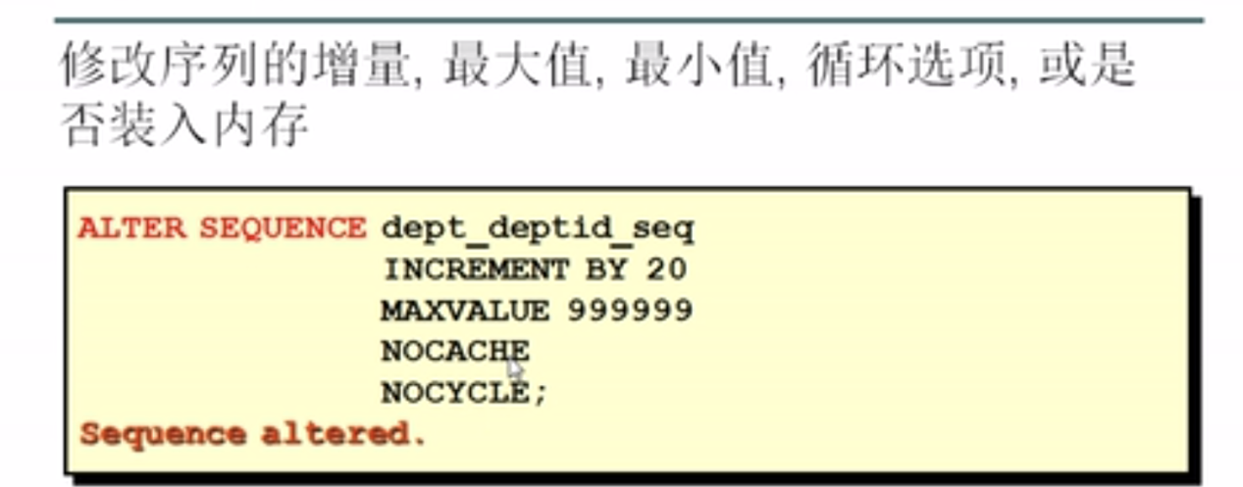



==============================索引==========================

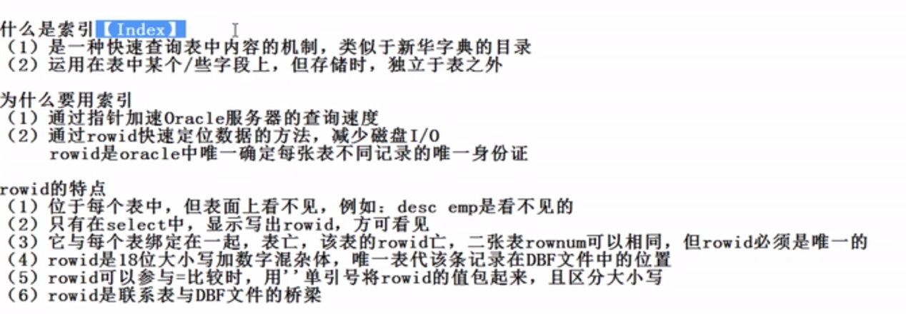

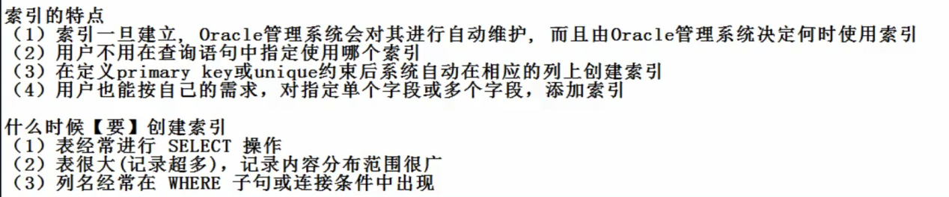

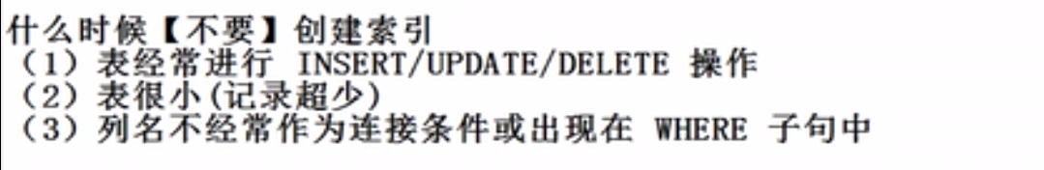

例子：查看索引

Select rowid,rownum,empno,ename,sal from emp;



Create index emp_empno_idx on emp(empno);



Create index emp_ename_job_idx on emp(ename,job);

注意：

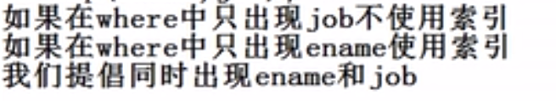



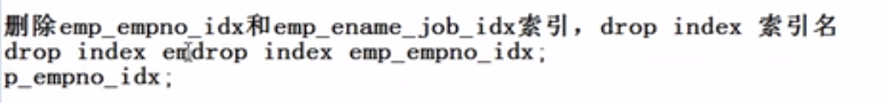

Drop index emp_empno_idx;